**Copy of BCC LogoBelmont City College**

**YR12 HUMAN BIOLOGY 2023 Unit 3**

**Task 2 Part B Test – Nervous System**

**Name:** …………………………………… Total Mark: /55

Time allowed: 55min

**Section One: Multiple Choice [10 marks]**

Place a ~~cross~~ through the selected letter.

1. A B C D 6. A B C D

2. A B C D 7. A B C D

3. A B C D 8. A B C D

4. A B C D 9. A B C D

5. A B C D 10. A B C D

**Section Two: Short answer 30 Marks**

**Question 11 [9 marks]**

1. The nervous system has several different subdivisions which have quite specific functions. Using the table below, state one **functional** difference between the following parts of the nervous system. (3 marks)

|  |  |
| --- | --- |
| **Two systems to compare** | **Main difference** |
| Afferent division vs efferent division of the peripheral nervous system |  |
| Central nervous system compared to the peripheral nervous system |  |
| Sympathetic vs Parasympathetic nervous system |  |

1. Describe the structure of the meninges (3 marks)

…………………………………………………………………………………………………………………..

…………………………………………………………………………………………………………………..

…………………………………………………………………………………………………………………..

…………………………………………………………………………………………………………………..

1. Describe the functions of the cerebrospinal fluid (3 marks)

…………………………………………………………………………………………………………………..

………………………………………………………………………………………………………………….

………………………………………………………………………………………………………………….

………………………………………………………………………………………………………………….

**Question 12 [7 marks]**

A reflex is a rapid response to a change in the internal and external environment.

The diagram below shows the main components of a reflex arc.

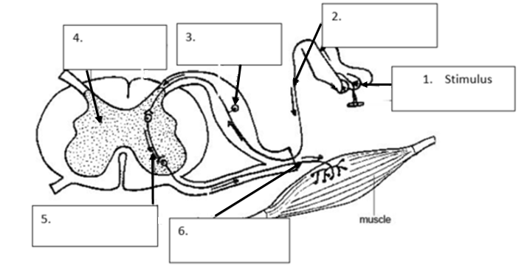

1. Identify the main components of the reflex arc indicated by the arrows by filling in the boxes on the diagram above. Number 1 has been done for you. (5 marks)
2. Explain why the reflex arc is considered to be protective. (2 marks)

………………………………………………………………………………………………………………

………………………………………………………………………………………………………………

……………………………………………………………………………………………………………….

**Question 13 [10 marks]**

Use the diagram below to answer the following questions.

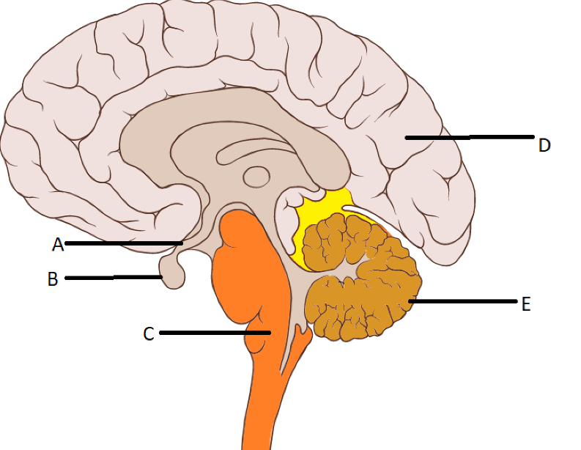

1. Name the following structures. (2 marks)

A:……………………………………………………

B:……………………………………………………

1. Describe the function of the following structures. (4 marks)

C: ………………………………………………………………………………………………………………..

…………………………………………………………………………………………………………………….

E:………………………………………………………………………………………………………………….

…………………………………………………………………………………………………………………….

1. D, the cerebrum is divided into four lobes. Name each of these lobes and state a function of each. (4 marks)

|  |  |
| --- | --- |
| Lobe | Function |
|  |  |
|  |  |
|  |  |
|  |  |

**Question 14 [4 marks]**

Below is an action potential graph, showing the outcome from two different stimuli on the same neuron. Looking at the graph below, answer the questions that follow.

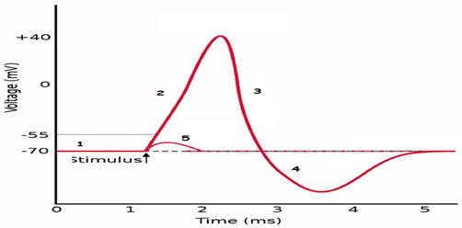

1. The first stimulus resulted in the line labelled with the number 5. Explain why the potential difference quickly returned to -70mV. (2 marks)

……………………………………………………………………………………………………………..

……………………………………………………………………………………………………………..

……………………………………………………………………………………………………………..

1. The second stimulus resulted in the line labelled with the numbers 2, 3 and 4. State TWO events related to the nerve impulse that could not possibly occur during the phases shown by the sections labelled 2, 3 and 4.

(2 marks)

………………………………………………………………………………………………………………

………………………………………………………………………………………………………………

………………………………………………………………………………………………………………

**Section Three: Extended Answer 15 marks**

**Question 15**

1. Caffeine has been known to help long haul truck drivers carry their load over long distances with minimum sleep. Caffeine results in increased neurotransmitter at some synapses.

Explain in detail how a nerve impulse is transmitted across a synaptic gap. (9 marks)

…………………………………………………………………………………………………………..

…………………………………………………………………………………………………………..

…………………………………………………………………………………………………………..

…………………………………………………………………………………………………………..

…………………………………………………………………………………………………………..

…………………………………………………………………………………………………………..

…………………………………………………………………………………………………………..

…………………………………………………………………………………………………………..

…………………………………………………………………………………………………………..

…………………………………………………………………………………………………………..

…………………………………………………………………………………………………………..

…………………………………………………………………………………………………………..

…………………………………………………………………………………………………………..

…………………………………………………………………………………………………………..

1. Some neurotransmitters have an inhibitory effect. Describe the effect they have on receptors at the post synaptic membrane, to cause inhibition of neurotransmission. (6 marks)

…………………………………………………………………………………………………………..

…………………………………………………………………………………………………………..

…………………………………………………………………………………………………………..

…………………………………………………………………………………………………………..

…………………………………………………………………………………………………………..

…………………………………………………………………………………………………………..

…………………………………………………………………………………………………………..

Additional Working Space if Needed

…………………………………………………………………………………………………………..

…………………………………………………………………………………………………………..

…………………………………………………………………………………………………………..

…………………………………………………………………………………………………………..

…………………………………………………………………………………………………………..

…………………………………………………………………………………………………………..

…………………………………………………………………………………………………………..

…………………………………………………………………………………………………………..

…………………………………………………………………………………………………………..

…………………………………………………………………………………………………………..

…………………………………………………………………………………………………………..

…………………………………………………………………………………………………………..

…………………………………………………………………………………………………………..

…………………………………………………………………………………………………………..

…………………………………………………………………………………………………………..

…………………………………………………………………………………………………………..

…………………………………………………………………………………………………………..

…………………………………………………………………………………………………………..

…………………………………………………………………………………………………………..

…………………………………………………………………………………………………………..

…………………………………………………………………………………………………………..

…………………………………………………………………………………………………………..

…………………………………………………………………………………………………………..

…………………………………………………………………………………………………………..

…………………………………………………………………………………………………………..

…………………………………………………………………………………………………………..

…………………………………………………………………………………………………………..